CS 255 System Design Document

UML Diagrams

UML Use Case Diagram

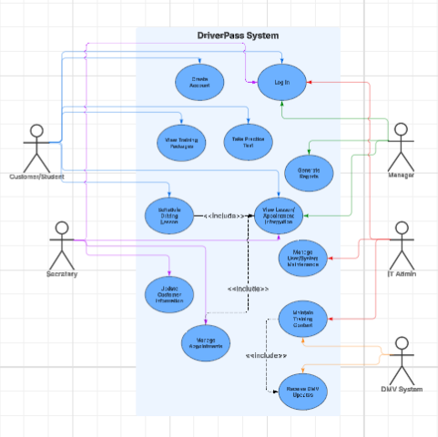

The use case diagram shows how different users interact with the DriverPass system. Customers can create accounts, log in, schedule lessons, and access training materials. Employees and administrators manage schedules, update information, and monitor system activity. This ensures all users’ needs are supported.

UML Activity Diagrams

Login / Register
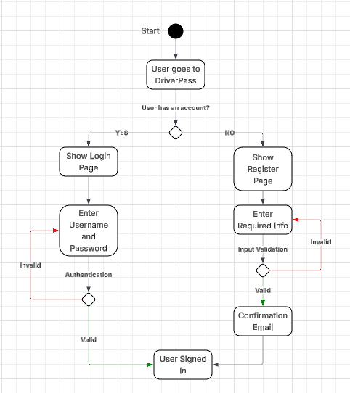

This activity diagram shows the process of a user creating an account or logging into the system. It includes entering information, validating credentials, and handling errors. This ensures users can securely access the system.

Schedule Lesson

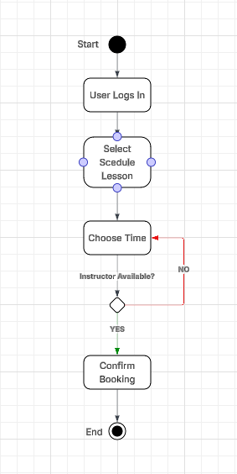

This activity diagram shows how a customer schedules a driving lesson. The process includes selecting a time, checking instructor availability, and confirming the appointment. If the selected time is unavailable, the user is prompted to choose another time.

UML Sequence Diagram

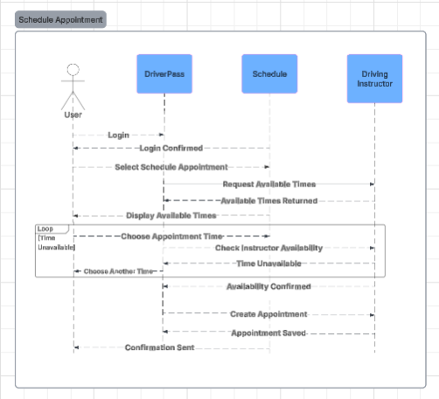

The sequence diagram illustrates how the system processes a lesson scheduling request. It shows the interaction between the user, DriverPass system, schedule, and instructor. The system checks availability creates the appointment and sends confirmation to the user.

UML Class Diagram

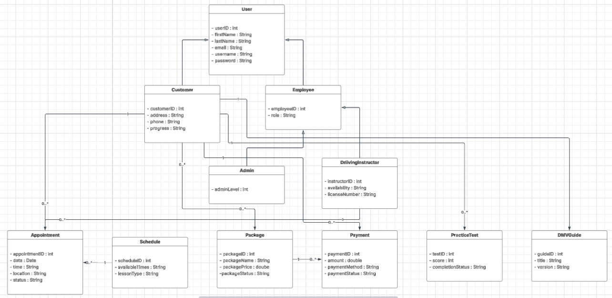

The class diagram represents the main components of the DriverPass system and their relationships. It includes user roles, scheduling, payments, and training features. These classes work together to support the overall functionality of the system.

Technical Requirements
The DriverPass system will require both hardware and software components to operate effectively. The system will be cloud based, allowing users to access it through web browsers on computers and mobile devices. This ensures flexibility and ease of access for customers and staff.

Hardware Requirements
- Reliable internet connection
- Server or cloud hosting environment
- Computers or mobile devices for user access

Software Requirements
- Web-based applications accessible through browsers
- Database system to store user accounts, appointments, and training data
- Web server software to manage system requests
- Secure login functionality to protect user information

Infrastructure Requirements
- Client-server architecture to support communication between users and the system
- Cloud-based hosting to allow remote access and scalability
- Ability to support multiple users at the same time without performance issues

Security Requirements
- User authentication through secure login credentials
- Protection of personal and payment information
- Controlled access based on user roles (customer, employee, admin)

